400
Note to Exhibitors: Always enter the plant in the lowest possible class number. Intergeneric hybrids should be classified with the genus they most closely resemble.

Oncidium Alliance
402. Brassia (includes Ada) species, hybrids, and intergeneric hybrids RESEMBLING Brassia (commonly called Spider Orchids). Flowers have similar sepals and petals, star-shaped; lip large, elongated, pointed.
404. "Odontoglossum" species, hybrids, and intergeneric hybrids RESEMBLING classical Odontoglossum. Petals wide and usually fringed or wavy, lip not dominate, similar color pattern.
406. Miltoniopsis species, hybrids, and intergeneric hybrids RESEMBLING the classical Pansy Orchid. Flowers large and round. Lip may have a waterfall pattern.
408. Miltonia species, hybrids, and intergeneric hybrids that generally have sepals and petals star-shaped, lip large and round.
410. Tolumnia species, hybrids, and intergeneric hybrids RESEMBLING Tolumnia. Small plant, no pseudobulb, leaves arranged in a fan.
412-414. Thick-leaf Oncidium Alliance
412. Psychopsis species, hybrids, and intergeneric hybrids RESEMBLING the classical Butterfly Orchid. Flowers single, sequential.
414. Thick-leaf Oncidium Alliance genera species, hybrids, and intergeneric hybrids not specifically mentioned above such as Trichocentrum, Oncidium, Grandiphyllum, etc. Leaves thick (leathery), can be terete or mule ear.
416. Thin-leaf Oncidium species, hybrids, and intergeneric hybrids, flowers with a natural horizontal spread of less than or equal to 3.0 cm (~1.2 in), all colors.
418-426. Thin-leaf Oncidium species, hybrids, and intergeneric hybrids, flowers with a natural horizontal spread greater than 3.0 cm (~1.2 in).
418. Flowers white (with or without markings).
420. Flowers yellow or brown (with or without markings).
422. Flowers purple or lavender (with or without markings).
424. Flowers red or orange (with or without markings).
426. Flowers other colors or mixed that do not fit in above classes.
430. Allied genera species, hybrids, and intergeneric hybrids not specifically mentioned above such as Gomesa, Rodriguezia, Rhynchostele, Aspasia, Comparettia, Rossioglossum, Zelenkoa, etc.

432. Best-grown plant from classes 402-430. (Trophy)

433. Best small flower from classes 402-430. (Trophy)
434. Best large flower from classes 402-430. (Trophy)

xx O R C H I D S H O W 2 0 2 3
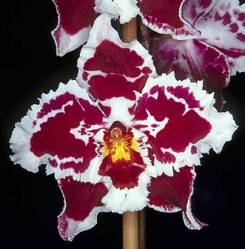
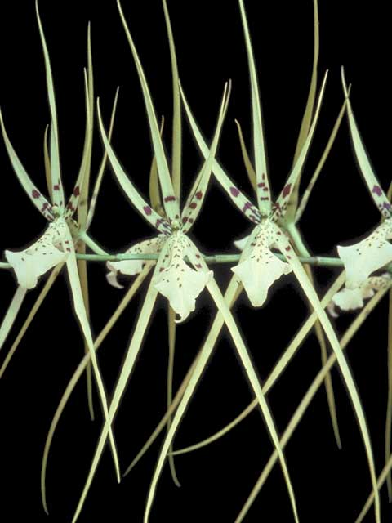
Note: Intergeneric hybrids should be classified with the genus they most closely resemble.
Oncidium Alliance Guide
402. Brassia (includes Ada) species, hybrids, and intergeneric hybrids RESEMBLING Brassia (commonly called Spider Orchids). Flowers have similar sepals and petals, star-shaped; lip large, elongated, pointed.
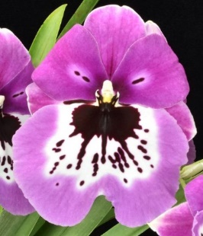
404. "Odontoglossum" species, hybrids, and intergeneric hybrids RESEMBLING classical Odontoglossum. Petals wide and usually fringed or wavy, lip not dominate, similar color pattern.
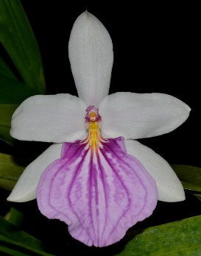
406. Miltoniopsis species, hybrids, and intergeneric hybrids RESEMBLING the classical Pansy Orchid. Flowers large and round. Lip may have a waterfall pattern.
408. Miltonia species, hybrids, and intergeneric hybrids that generally have sepals and petals star-shaped, lip large and round.
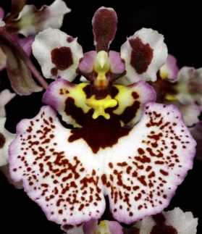
410. Tolumnia species, hybrids, and intergeneric hybrids RESEMBLING Tolumnia. Small plant, no pseudobulb, leaves arranged in a fan.
412-414. Thick-leaf Oncidium Alliance
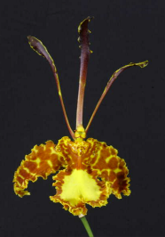
412. Psychopsis species, hybrids, and intergeneric hybrids RESEMBLING the classical Butterfly Orchid. Flowers single, sequential.
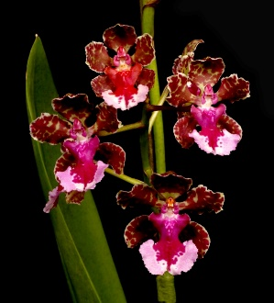
414. Thick-leaf Oncidium Alliance genera species, hybrids, and intergeneric hybrids not specifically mentioned above such as Trichocentrum, Oncidium, Grandiphyllum, etc. Leaves thick (leathery), can be terete or mule ear.
416. Thin-leaf Oncidium species, hybrids, and intergeneric hybrids, flowers with a natural horizontal spread of less than or equal to 3.0 cm (~1.2 in), all colors.
418-426. Thin-leaf Oncidium species, hybrids, and intergeneric hybrids, flowers with a natural horizontal spread greater than 3.0 cm (~1.2 in).
418. Flowers white (with or without markings).
420. Flowers yellow or brown (with or without markings).
422. Flowers purple or lavender (with or without markings).
424. Flowers red or orange (with or without markings).
426. Flowers other colors or mixed that do not fit in above classes.
430. Allied genera species, hybrids, and intergeneric hybrids not specifically mentioned above such as Gomesa, Rodriguezia, Rhynchostele, Aspasia, Comparettia, Rossioglossum, Zelenkoa, etc.
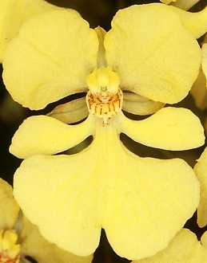
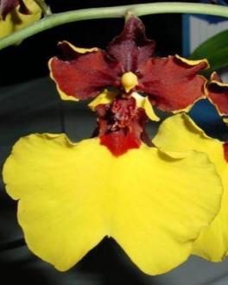
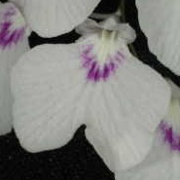
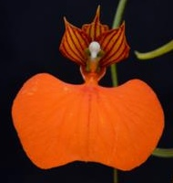
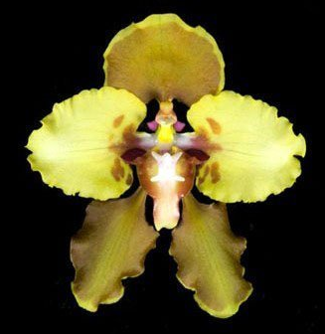
Comparettia
Cyrtochillum
Zelenkoa
Fernandezia
Ionopsis
Gomesa

