Fort Wort Orchid Society Show & Sales
“The Shocking Beauty of the Orchid World”
SWROGA Spring Meetings
April 10th and 11th, 2020
The Forth Worth Botanic Gardens, Forth Worth, Texas

ITINERARY

Friday, April 10th 8:00 AM to 1:00 PM Vendor and Exhibit Set-up*
1:00 PM to 5:00 PM Show & Sales Open to the Public

5:30 PM to 6:30 PM SWROGA Committee Meetings
6:30 PM to 8:00 PM SWROGA Directors Meeting (Dinner provided)

Saturday, April 11th 8:00 AM to 1:00 PM Judging
1:00 PM to 5:00 PM Show & Sales Open to the Public
5:00 PM Show Breakdown

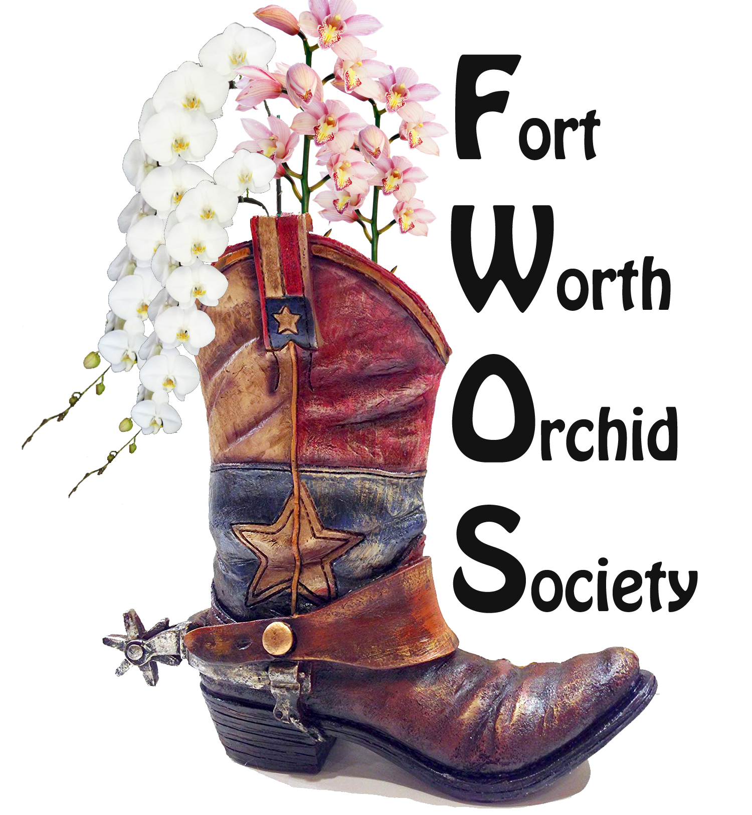

*See Forms for Vendor and Exhibit Registration

